Monitoring User Resource Utilization

Web Application for Monitoring Cloud Resource Utilization

Amsal Naeem

CIDSE ASU

anaeem1@asu.edu

Parneet Kaur

CIDSE ASU

pkaur8@asu.edu

Vanthana Sachdev

CIDSE ASU

vsachde2@asu.edu

*Abstract* — In a Cloud environment, each user allocates some resources according to his/her requirements. However, there is no guarantee that these resources are sufficient or efficiently used, i.e., there could be under or over utilization. The scope of the project is to develop a web application as an interface for the user to monitor the utilization of his/her allocated resources; based on observations, suggestions will be given to the user regarding how to maximize the use of their resources or which resources to add to the pool of resources to facilitate user task completion.

Keywords— Cloud platform, Devstack, Cloud services, Heat, Ceilometer, Web application, RESTful API

# Introduction

1. The problems to be addressed in this project.
   1. Monitoring resource utilization for each user.
   2. Based on statistics give suggestions to user regarding allocated resources.
   3. Provide interface to user to view the status of their allocated resources
2. Why are these problems are important?
   1. Cloud infrastructure is meant to provide resources to the users. These resources need to be managed to ensure full and efficient utilization. The motivation behind this is to make sure that no resources go to waste. This will promote scalability and allow more users to take advantage of these resources.
3. Applied technologies and solutions to address these problems.
   1. Devstack (Cloud platform)
   2. Devstack/Openstack services. Predominantly Heat and Ceilometer
   3. RESTful API to extract data from cloud services and post data to the web application
   4. Web application for user for user using HTML, CSS, JavaScript, Node Js, Ubuntu Server
4. Expected outcomes of this projects.
   1. Web interface to monitor the utilization status of resources allocated on the Devstack/Openstack cloud platform.
5. Project management plan
   1. The tentative plan is to finish building the Web Application (Parneet Kaur) and finish the setting up of the cloud infrastructure on Devstack, along with gathering statistics (Amsal Naeem and Vanthana Sachdev) by the Second Phase Deadline. The extraction of information and integration of results from Phase 2 with the front web application should be completed by the final deadline (Vanthana Sachdev, Parneet Kaur, Amsal Naeem).

# System Models

## System Model

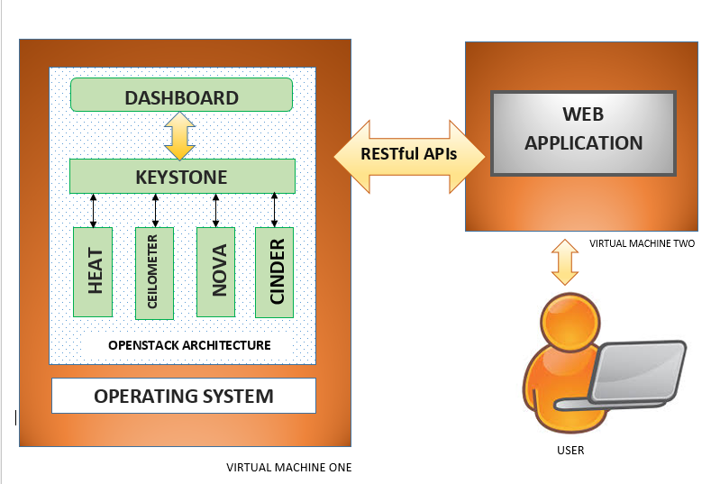

The system model comprises of the following:

* + 1. Cloud Environment: The Devstack platform will be used to set up the cloud environment. Heat, Nova, Ceilometer will be the main services used.
    2. Web Application: The front end of the webportal will be a user interface created using HTML, CSS and JavaScript (on the front end) and on the server side, server will be created Node JS. A private database will be created to store the information of each user.

## Software

Environment: Devstack

APIs: RESTful API

Services: Heat, Ceilometer, Nova, Neutron, Swift, Cinder, Glance

Tools: Ububtu Server

Programming Language: Python, HTML, CSS, JavaScript, NodeJs

# Project Description

## Project Overview

The project goal is to provide users with a web interface to view the status of the allocated resources in a cloud. This information will help users analyze their application requirements in a better way. Devstack will be used as the cloud platform and its services will be used to gather metrics for the resources. Out of the gathered data, only the data related to a particular user is made available on the web interface for the user. Also, based on the data, cloud management may generate a report suggesting the resource requirements for user application.

## Task 1 : Setting up Cloud environment

This task involves setting up the Devstack platform on the allocated virtual machines in the Thoth lab. Understanding Devstack architecture, configuring the required services, interacting with devstack services will also be part of this task

## Task 2: Gathering metrics

After having a good understanding of cloud, devstack services will be used to gather metrics. Mainly used services include heat, ceilometer, nova, neutron, swift, cinder, glance.

## Task 3: Web application

A web portal will be created for user to get the information of resources usage. The front end of the webportal will be a user interface created using HTML, CSS and JavaScript (on the front end) and on the server side, server will be created Node JS. A private database will be created to store the information of each user.

## Task 4: Integration.

This is the last and most important phase of the project. This involves integrating front end application and the under laying metrics collection on cloud. The monitored statistics that are gathered and processed at the cloud is made available to user through this web interface.

## Project Task Allocation

Describe the workload for the group members and they responsibility for the proposed tasks. Use table if possible to highlight the proposed workload and allocations. Use percentle to indicate the workload and identify the project lead of this project.

| **Task** | **Sub-Task** | **Team Member** | **Work Percentage** |
| --- | --- | --- | --- |
| Cloud Setup | Setup | Vanthana/Amsal | 7.5 |
| DevStack Configuration | Vanthana Sachdev | 10 |
| DevStack Deployment | Amsal Naeem | 10 |
| Services Testing | Amsal/Vanthana | 7.5 |
| Web Application Setup | Environment Setup | Parneet Kaur | 3 |
| Server-Side Development | Parneet Kaur | 8 |
| Client-Side Development | Parneet Kaur | 8 |
| Application Integration | Amsal Naeem | 3 |
| Software Testing | Parneet/Amsal | 3 |
| Connecting the Web application and cloud | Network Setup | All | 12.5 |
| Server-Side Methods Development | Amsal/Parneet | 12.5 |
| Integration Testing | All | 5 |
| Documentation | Reports | All | 3 |
| Power-point Presentation | All | 3 |
| Demo | All | 4 |

## Deliverables

Web Portal to access cloud, backend monitoring service and a detailed Readme.

## Project Timeline

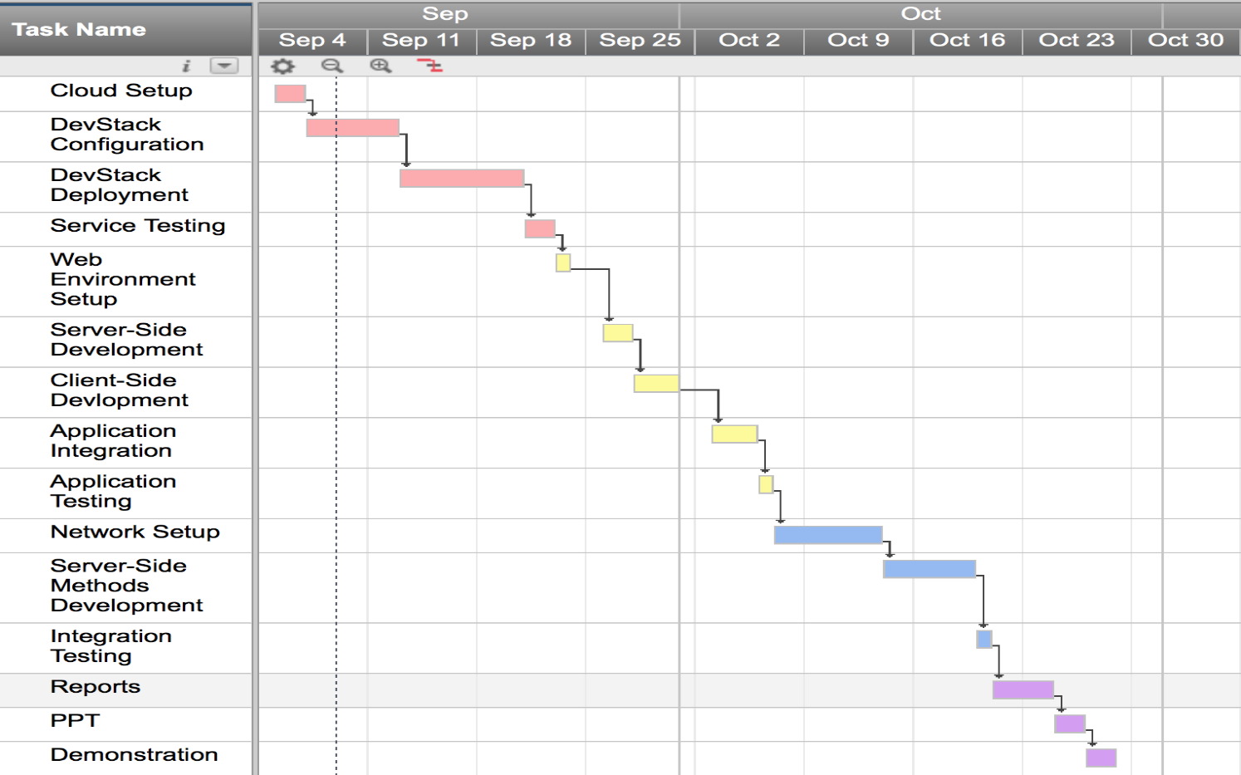

# Risk Management of the project

|  |  |  |
| --- | --- | --- |
| **Risk Description** | **Risk** | **Mitigation Strategy** |
| Network Connectivity | High | Periodically checking n/w connectivity |
| Machine Overload | High | Use machine with higher configuration |
| Data Loss | Medium | Implementing a cloud based data backup |

# Conclusion

The need of the hour is to efficiently and cost effectively utilize limited resources to build and complete tasks in a scalable manner, especially with most companies and institutions offloading their work to Cloud. To address this problem, which is and will in the future gain more notoriety, we are building a Web Application to monitor resource utilization.

The future scope is extending the application to monitor resources on per hour basis.

##### Acknowledgment

We sincerely thank our professor, Dr. Dijiang Huang, for giving us the opportunity to understand and work on an open-source cloud platform, which will aid our careers in the field of upcoming technology. We would also like to thank our Teaching Assistant, Ankur Chowdhary, for assisting us in our endeavor to build a good solution for monitoring cloud resources and for patiently answering all our questions and clearing all our confusions.

##### References

1. G. Eason, B. Noble, and I. N. Sneddon, “On certain integrals of Lipschitz-Hankel type involving products of Bessel functions,” Phil. Trans. Roy. Soc. London, vol. A247, pp. 529–551, April 1955. *(references)*
2. J. Clerk Maxwell, A Treatise on Electricity and Magnetism, 3rd ed., vol. 2. Oxford: Clarendon, 1892, pp.68–73.
3. I. S. Jacobs and C. P. Bean, “Fine particles, thin films and exchange anisotropy,” in Magnetism, vol. III, G. T. Rado and H. Suhl, Eds. New York: Academic, 1963, pp. 271–350.
4. K. Elissa, “Title of paper if known,” unpublished.
5. R. Nicole, “Title of paper with only first word capitalized,” J. Name Stand. Abbrev., in press.
6. Y. Yorozu, M. Hirano, K. Oka, and Y. Tagawa, “Electron spectroscopy studies on magneto-optical media and plastic substrate interface,” IEEE Transl. J. Magn. Japan, vol. 2, pp. 740–741, August 1987 [Digests 9th Annual Conf. Magnetics Japan, p. 301, 1982].
7. M. Young, The Technical Writer’s Handbook. Mill Valley, CA: University Science, 1989.